Matthew Trembley

7/17/2022

Southern New Hampshire University

CS-360

Project 1 – Option 1: Inventory App

The application I have chosen is Option 1: Inventory App. This application is supposed to be used to track items within a warehouse. The most important functions for this app are as follows: A database with two tables, one to store inventory items and one for user logins. A login screen that can also be used to create new users. A screen that displays items in the inventory. Some mechanisms that support the functionality of adding and removing items, incrementing or decrementing quantities of items, and a notification that will alert the user when an item has been reduced to 0. This app will use a few different screens to successfully create a user-friendly experience.

There are a few different types of users within a warehouse that may use this, like general workers, managers, and front office users. All these users can potentially have different permissions for certain functionalities further down the road. A general worker may be able to edit the quantities as they move products around or a manager can add and remove items from the inventory list. A front office user may be able to use it to order more of a specific item, if need be, pending being alerted to 0 – as that alert mechanism is required. Each of these users play a different role in their workplace, as they will in using this application. Thus, the idea of permissions for different kinds of functionalities can be input into the application sooner rather than later. The main goal of this app is to make the tracking of items easy and painless, so the application’s UI needs to fit that bill – easy, fast, painless, efficient. This app will be centered around 4 main screens, although more will be needed to consider the app “complete”. Below is a wireframe of the “log in” screen.

This simple wireframe allows the user to login with valid credentials. If they are a first time user, or just needing to create an account, a clickable text will be available to take them to a page where they can set that up. Either way, these credentials will be stored in a database that will be called to every time the user attemps a login, or when new accounts are being created. After this step, whether it be a new account or returning user, they will open to a new page pictured below.

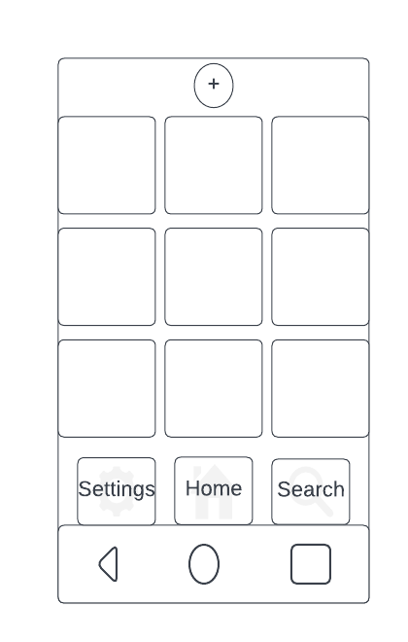

This second wireframe is a rough idea of what the “Home” screen will look like. At the top is a clickable button with a addition symbol, which will allow users to add new items to the inventory. Each box represents an item within inventory, where the user may click on each and find information relevant to the respective box. All of these items will be stored in a second database which will be called upon and editted pending the user clicking either the add button or a specific item. Last, there are 3 buttons whose complete features are yet to be determined. The next wireframe is when a user clicks on the add button.

This wireframe is another rough draft of an “add item” page. When the user touches the “add” button on the home screen, they will be brought to this screen where they will need to add a name, description, and quantity of the item. The name and description will be stored as a string, editable by the user. The quantity and alart quantity, stored as an integer, will be editable by a user as well. Alert quantity (which will be defaulted to 0) is to alert the user when the “Current Quantity” falls to 0, or to a user specified threshold. Last is a photo of the item, which will be displayed at the home page. When a user clicks on a square at the home page, they are brought to another screen almost identical to this – pictured below.

This last wireframe is of when a user clicks an item square on the home page. They are brought to a page similar to the “add” page. The item name, description, and quantity is set and is editable in cases like spelling mistakes or improper naming. The user has the ability to increment or decrement the current quantity by 1 with the + or – buttons, respectively. Last, the user will have the ability to delete the item in cases of the warehouse no longer supplying or storing the item.

This application relies heavily on a good database set up. Almost every activity the user can do will require interacting with one of two databases, whether it be the login credential database or the product database. For example, when a user creates a new username and password, they are tapping into the credential database in which their new logins will be stored. Another example, a user may try to search for an item (pending available feature) by name, and the database will be queried for the correct entry. Each functional app requirement will not only be represented in the code, but will also create the foundation of the application.